Type here your abstract title: please use lowercase letters and do not capitalize words

Paul Langevin*a*, Lev D. Landau*b*, Carl F. Gauss*c*

*a* Collège de France, Paris, France

*b* Institute for Physical Problems, Russian Academy of Sciences, Moscow, Russia

*c* University of Göttingen, Göttingen, Germany

This is the MS-Word template file for the abstracts to be submitted to the TopDyn Workshop [1]. Use this file to prepare your abstract with MS-Word. You can find additional templates for other word processors on the conference website [1]. Please make proper use of the provided paragraph styles: check with this template on how to use them. Please note that the first paragraph of the abstract body has a style of its own, different from the style of the other paragraphs of the abstract body.

To prepare your abstract, replace title, authors, affiliations and abstract body. Short mathematical expressions and symbols can be placed in-line, *e.g.*: . More complex mathematical expressions or equations can be typed in independent lines using the equation editor:

. (1)

Insert a tab before the equation to align it to the centre, then a tab before the equation number (1) to align it to the right. Also note that paragraphs immediately after equations have a style of their own, lacking the first line indent.

You can add figures (see e.g. fig. 1) using text boxes and inserting both the figure and its caption inside the text box. You can also add references [2]: please note that the separator line before the references is an empty paragraph with style of its own.

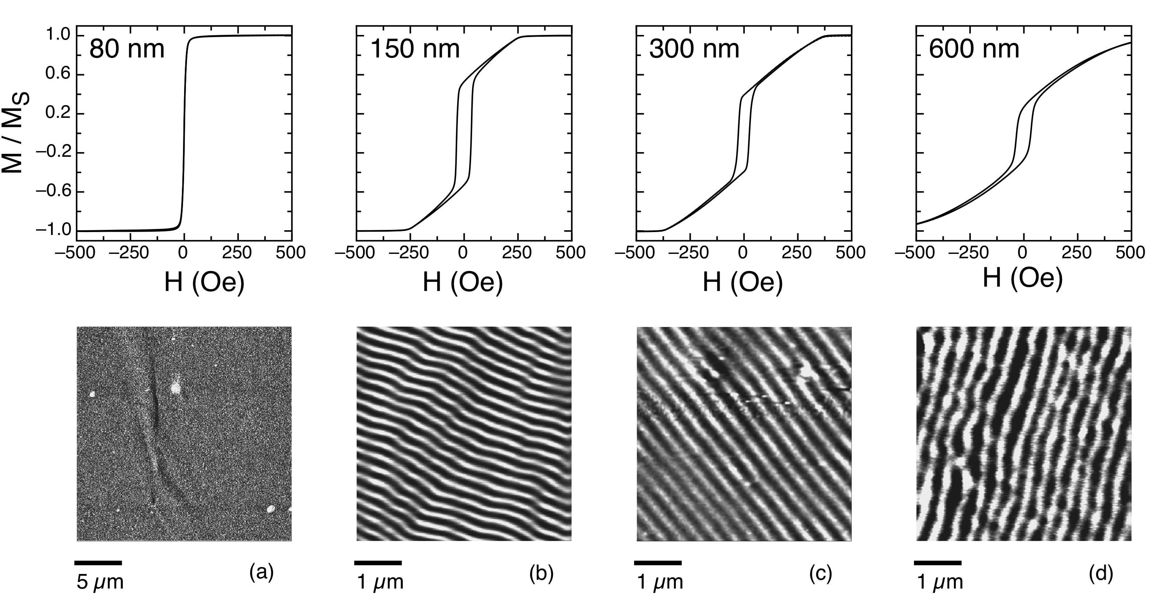

Figure 1: Top row: hysteresis loops of samples with different thickness. Bottom row: corresponding MFM images at remanence.

Please stay within the one-page limit: abstracts exceeding this limit will be rejected. Thank you for contributing to the TopDyn Workshop.

[1] https://www.petaspin.com/topdyn-workshop/

[2] L. Néel, Rev. Mod. Phys. **25** (1953), 58-63.